Module 9 Discussion

Using the 100 Things Every Designer Should Know About People reading assignment, select two (2) of the "things" you read about, include the number and title of the "thing" (i.e., #36 Time is Relative) , and then do two embellishments, one embellishment and one visual example, or two visual examples.
- Embellish: Tell us something that the reading did not tell us on that specific "thing" or embellish on what was presented. Be sure you are adding meaningful content to the conversation and not just making noise. Your addition can be a link to an article, or you can write out your embellishment.
- Visual Example: Provide us with a graphic example that is relevant to web design. This can be something you create or something you find. Again, be sure to add meaningful content to the conversation.

Topic #75: If People Can’t Feel, Then They Can’t Decide
Embellishment:
This topic got me thinking. The book states that if you are unable to move your facial muscles, you will likely feel a much-dampened emotional reaction. But, as with all things in the human body, I felt this had most to do with the brain's interpretation. So, something makes you sad, and that signals your brain that sadness is occurring. If that also sends the signal to your face to make the “sad face,” but your face can’t react, your face stays neutral. Now, your face making a sad face also sends a signal to your brain that something is making you sad. Since that hasn’t happened, there are fewer “sadness” signals going to the brain, and you may feel less sad.
I decided to look for research on this topic and found a 2015 paper by Barrett and Simmons. I did not read the paper fully, but I read the abstract, and it mentions that they intended to prove exactly this effect (but in much more technical terms) (Barret & Simmons, 2015).
Now, how does this apply to web design? The basic idea is that the level of emotion felt depends on the number of signals (stimuli) the brain receives. So, if you want to create a site that generates a stronger “happy” emotion, you need to put those little happiness cues all over, not just one here or there. But more than that, the website’s “facial features” are its interactivity. This is where things happen as you interact with the site: a button that presses, links the hover, slight transitions (instead of simply changing color when you hover over it, making it take .3 seconds and having a “fade” transition so it’s not so abrupt), using “happy colors.”
An example of this might be with a button:
button:hover {
transform: scale(1.05);
transition: 0.2s ease-in-out;
}
This makes the button grow to 105% size over .2 seconds when you hover over it. Adding feedback to the button (this works two ways, gives the feedback that this is indeed a button, and it helps make the user feel like the website isn’t as flat and emotionless, and have a better experience.

Topic #76: People Are Programmed to Enjoy Surprises
Embellishment/ Visual Example:
So many people enjoy stories with unpredictable plot twists and endings. This feeds on the idea that people enjoy surprises! If a story is predictable, even if it’s good, it might not stand out and be memorable. But when it ends with a surprise or unexpected twist… it sticks with you. One famous example is in The Empire Strikes Back when Vader says to Luke Skywalker, “No, I am your father.” This twist is still considered an epic reveal to this day, nearly 50 years later, because it surprised so many people. At the time, it was a novel idea that hadn’t been done before in popular culture. Now, it’s been ripped off so many times that it’s lost its shock factor.
Relating this to web design, if you want to build something that people will talk about for the next half-century, you need to do something shocking like this. But it only works if people are emotionally invested to begin with! You also have to not alienate your user base in the process. For example, if you “shock” your users by drastically changing the way they interact with the internet, and it makes it harder for them…. Your site is dead. But, if you make a web-based program that used computer-based learning to be able to take “conversational” text and give a reply, which can help you search the internet more effectively than regular search engines because it allows you to more easily tailor your search more like you are talking to someone (emotional and social cues), and tweek results easier by saying what it did wrong and clarifying (while keeping the context from before):
Visual Example of exactly how I found my scholarly source for topic 75 above:
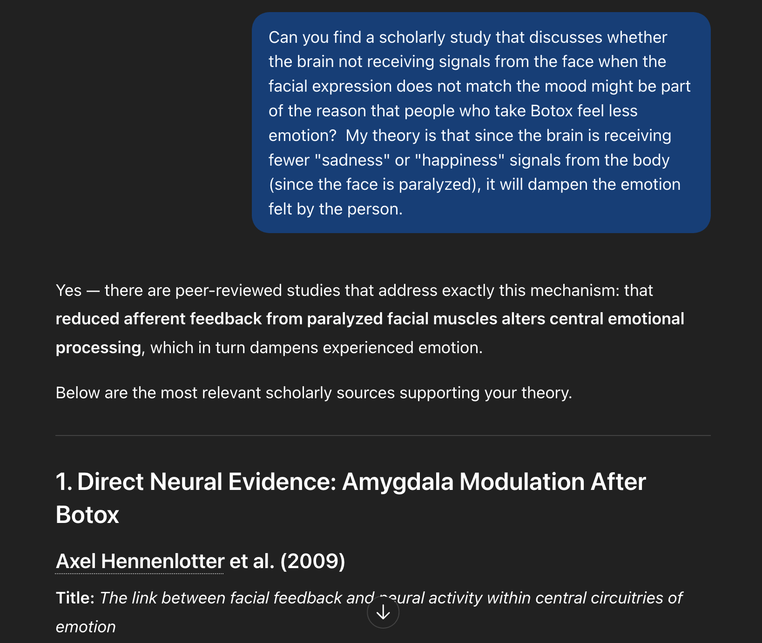
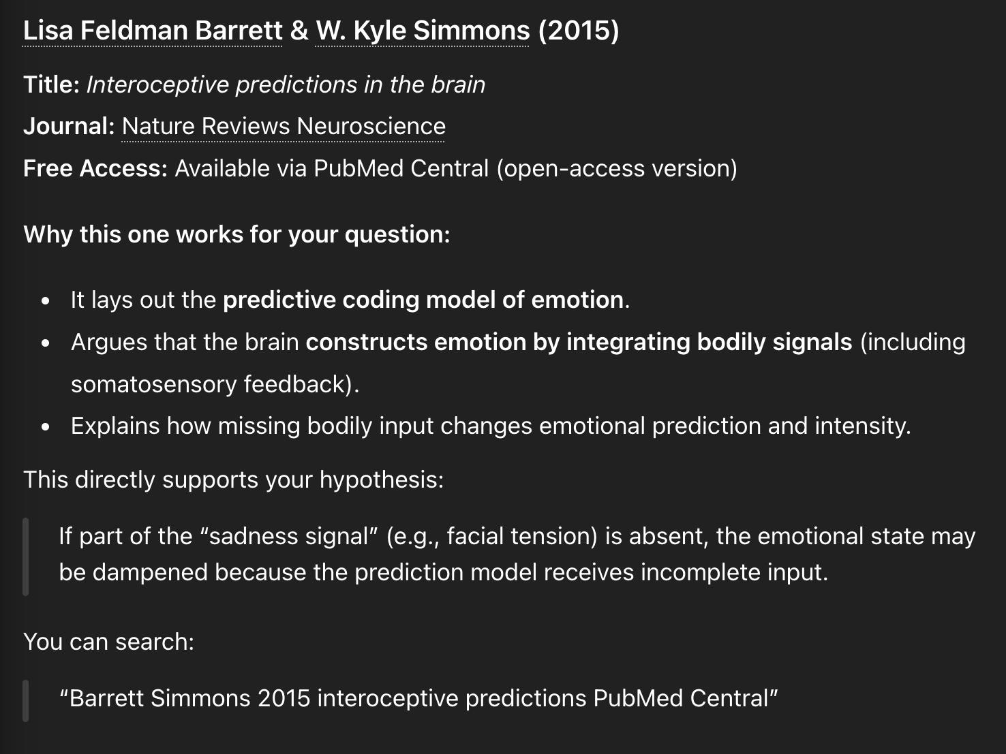

IMPORTANT NOTE:
Generative AI is NOT SMART. But it can lead you to good sources! As always, you need to use your own judgement on the sources it provides, and make sure that you feel they are scholarly and trustworthy.

Barrett, L. F., & Simmons, W. K. (2015). Interoceptive predictions in the brain. Nature reviews. Neuroscience, 16(7), 419–429. https://doi.org/10.1038/nrn3950

